

SUPERIOR UNIVERSITY LAHORE
GOLD CAMPUS

NAME: MUHAMMAD MOIZ RAZA
ROLL NO: SU92-BSAIM-F24-061
PROGRAM: ARTIFICIAL INTELLIGENCE
SEMESTER: 4th SEMESTER
SECTION: BSAI-4A
SUBJECT: PROGRAMMING OF AI (LAB)

Submission Title: LAB TASK 11
Submitted To: Sir Rasikh Ali

Task : Describe the Difference Between the Following Concepts:

1. LangChain

2. LLMs (Large Language Models)

3. RAG (Retrieval-Augmented Generation)

4. FAISS (Facebook AI for Semantic Search)

5. Vector

6. VectorDB

7. Generative AI (GenAI)

8. GANs (Generative Adversarial Networks

LangChain

LangChain is a tool or framework that helps developers easily build AI applications using large language models (LLMs). It connects the AI model with things like documents, APIs, memory, and other tools so that the AI can do more than just chat—it can actually perform tasks like answering from files or using external data.

LLMs (Large Language Models)
Large Language Models are powerful AI systems that are trained on a huge amount of text data. They learn how humans write and speak, so they can understand questions and respond in a very natural way. They are used for tasks like chatting, writing essays, summarizing information, translating languages, and even coding.

RAG (Retrieval-Augmented Generation)
RAG is a smart method that improves AI answers by first searching for relevant information from external sources (like documents or databases) and then using that information to generate a better and more accurate response. It helps the AI avoid guessing and reduces wrong answers.

FAISS (Facebook AI Similarity Search)
FAISS is a fast search tool created by Meta that helps find similar pieces of data very quickly. It works with vector data and is mainly used when we want to search based on meaning instead of exact words, like finding similar sentences or images.

Vector
A vector is simply a way of converting data (like text or images) into numbers so that a computer can understand it. These numbers represent the meaning of the data, so similar meanings have similar vectors.

VectorDB
A Vector Database is a special type of database that stores these vectors and helps quickly find similar ones. It is used in systems where we need smart searching based on meaning, like recommendation systems or AI search engines.

GenAI (Generative AI)
Generative AI is a type of AI that can create new things like text, images, music, or videos. Instead of only analyzing data, it can generate new content that looks human-made. Chatbots and image generators are examples of GenAI.

GANs (Generative Adversarial Networks)
GANs are a type of AI where two models compete with each other. One creates fake data (like images), and the other tries to detect if it is real or fake. Over time, the generator becomes so good that it can create very realistic images or data.

DIFFERNCE
Concept | Type | What it is | Usage (How it is used) | Real-world Example
LLMs | AI Model | Deep learning model for language understanding and generation | Used to answer questions, write content, code, and conversations | ChatGPT, Gemini
GenAI | AI Category | AI systems that generate new content | Used in text generation, image creation, music, and videos | DALL·E, GPT, Midjourney
LangChain | Framework | Tool to connect LLMs with tools and data | Used to build chatbots, AI agents, and workflow automation systems | AI assistants that read PDFs and answer questions
RAG | Architecture | Combines search system with LLM | Used when AI needs accurate answers from documents or databases | Chatbots that answer from company documents
FAISS | Library | Fast vector similarity search engine | Used to quickly find similar text, images, or embeddings | Google-like semantic search systems
Vector | Data Representation | Numbers representing meaning of data | Used to convert text/images into machine-understandable format | Word embeddings like Word2Vec
VectorDB | Database | Stores and searches vector embeddings | Used for AI search engines and recommendation systems | Pinecone, Weaviate
GANs | AI Model | Two networks that generate realistic fake data | Used to create images, deepfake videos, and data synthesis | AI-generated faces, art images

VISUALIZED FORM OF COMPARISON
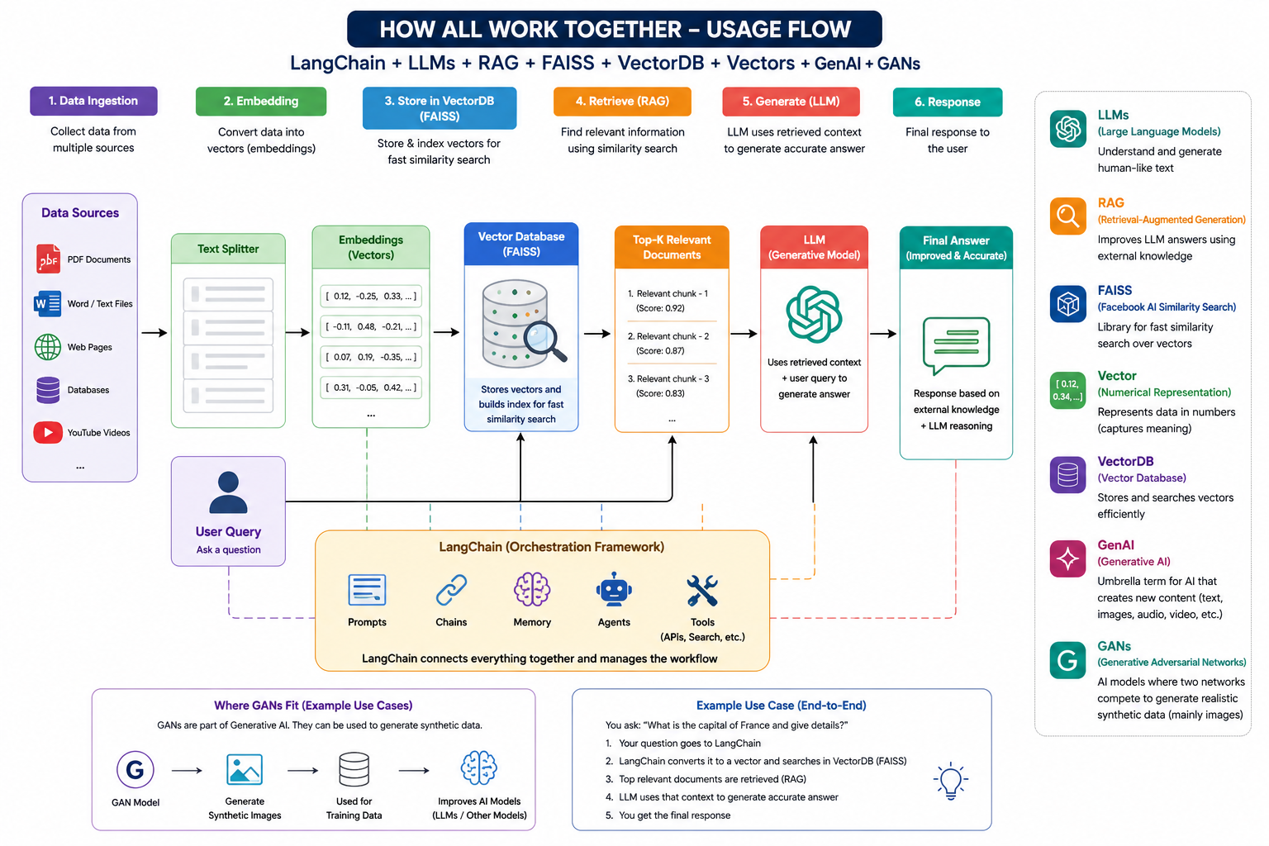

THE END

